**Notes for Multi Project Deployment – Cloud Build**

1. 3 Projects:

* Project A (region1)
* Project B (region 2)
* Project C (region 3)

Create a global cloud build trigger in project B (decide a host project out of the 3 regions).

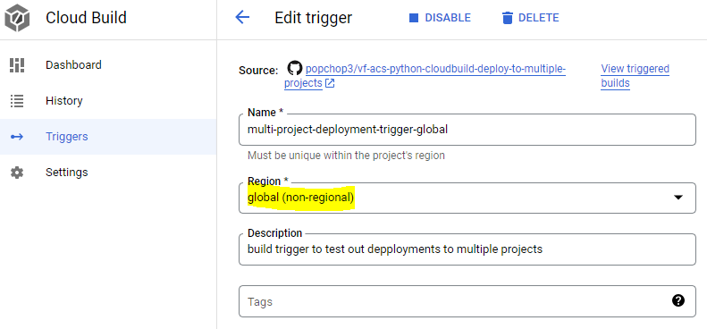

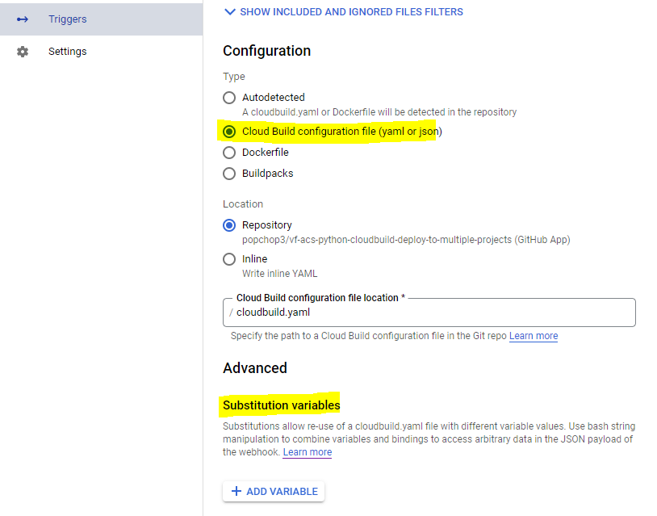

For now, don’t need to add any substitution variables as I am defining them in the cloudbuild.yaml file like so. Am thinking in future



1. Grant the cloud build service account permissions for cloud functions developer and service account user. (this is the default service account used by cloud build)

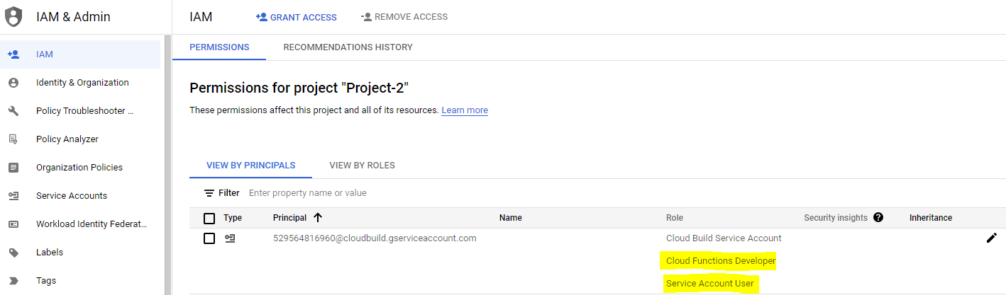

1. In order to ensure your cloud build can deploy to other projects, in your main project (project2) you need to go to the Runtime Service Account of your cloud functions service(by default for gen1 - **PROJECT_ID @appspot.gserviceaccount.com)** and select it, then click to grant access. Then in the “add principles” section, choose the default cloud build service account (the one with the functions developer role) , and assign this new principle. As you are doing in your main project, it will probably say this has already been done.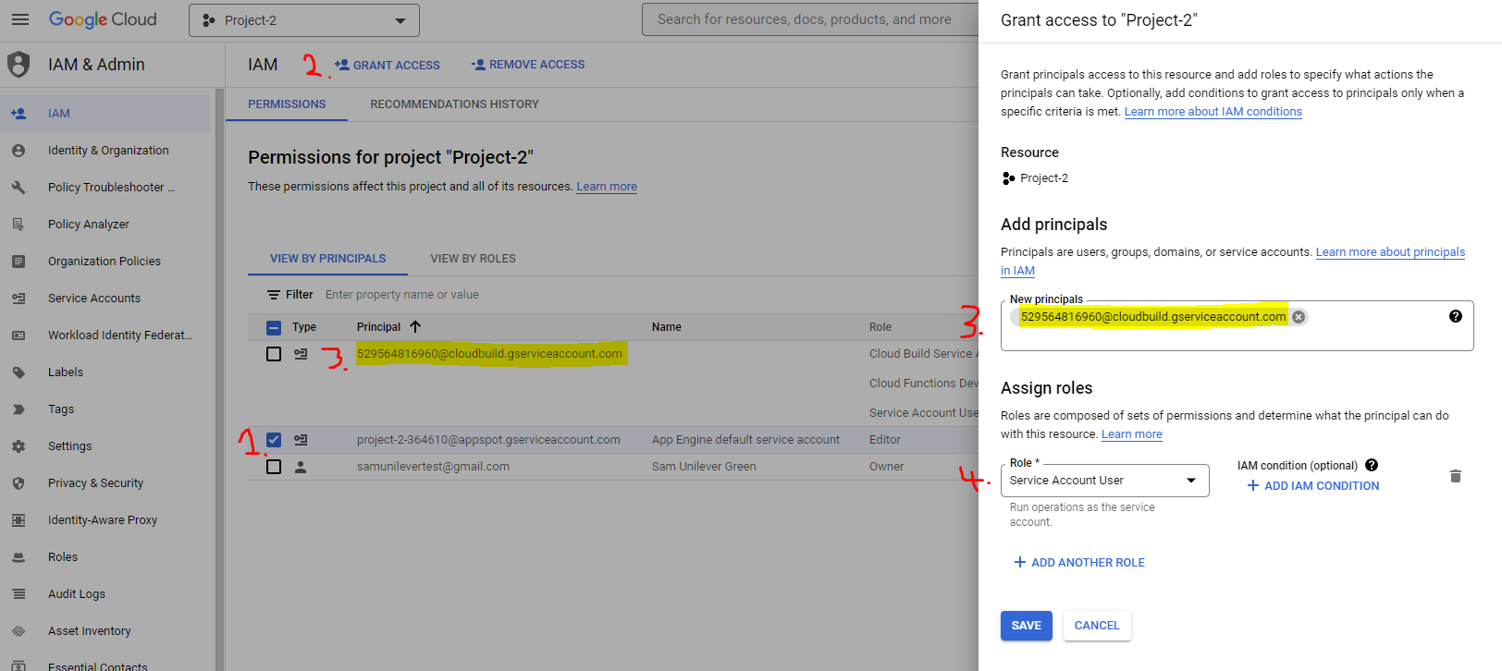
2. Then, in your other 2 projects (project 1 and project 3) you need to go to IAM and click on the default appspot service account again, and add a new principle of the cloud build service account in your main project(project 2 – copy it’s email). Then add 2 roles to that – “Service Account User” and “Cloud Functions developer”.

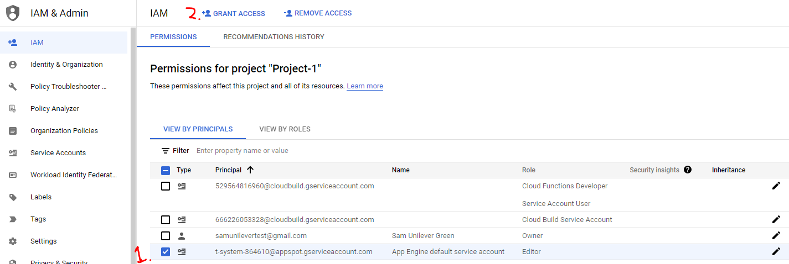

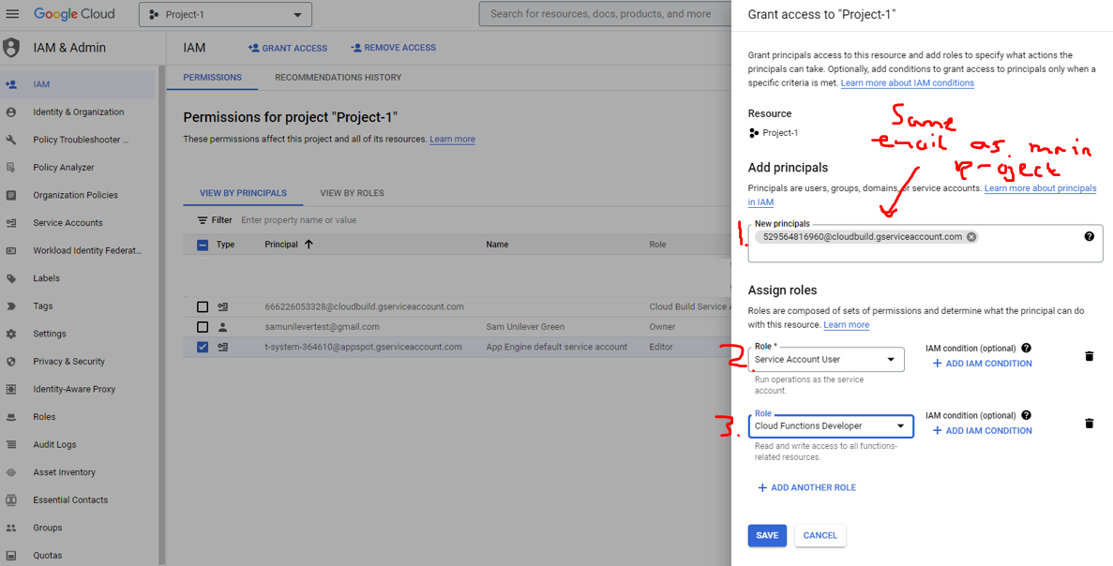

1. This should then let you deploy across 3 projects at the same time